BIRD IMPACT ASSESSMENT STUDY

Cape Peninsula Strengthening Project

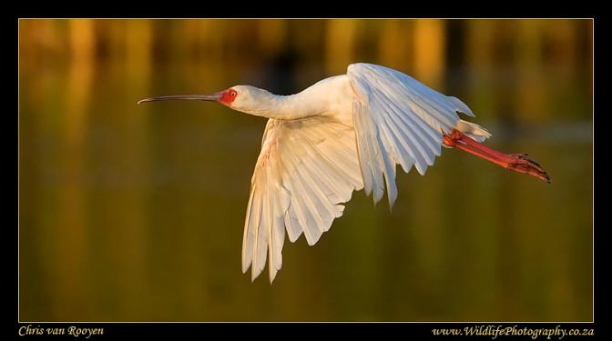

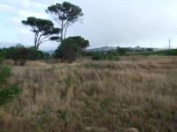

May 2011

Prepared by:

Chris van Rooyen Consulting
30 Roosevelt Street
Robindale
Randburg
2194
South Africa
Tel. International: +27824549570
Tel. Local: 0824549570
Fax: 0866405205
Email: vanrooyen.chris@gmail.com

1 INTRODUCTION & BACKGROUND

Eskom Transmission is proposing to strengthen the Cape Peninsula transmission network by constructing the following infrastructure:

- One 400kV double circuit Transmission power line of approximately 23km from the existing Firgrove substation to a proposed new substation in Mitchell’s Plain; and
- One 400kV single circuit Transmission power line of approximately 7km from the same proposed new substation in Mitchell’s Plain indicated above to the existing Philippi substation proposed to be upgraded. The upgrade of the Philippi substation will entail the addition of a transformer within the existing site.
- Following a request from an interested and affected party at the Public Open Day, an additional alternative was investigated for the Firgrove-Mitchell’s Plain project. It was determined that the connection of Stikland to Mitchell’s Plain could provide Eskom with the same result as the connection of Firgrove to Mitchell’s Plain. In addition, this would mean a reduced corridor to consider as opposed to the corridor of Firgrove-Mitchell’s Plain as an alternative.

Chris van Rooyen Consulting was appointed by BKS to conduct an avifaunal impact assessment study for this project.

A map of the study area indicating the different route options is attached as Appendix A.

1.2 Terms of reference

The terms of reference for this impact assessment study are as follows:

- Describe the affected environment;
- Indicate how birdlife will be affected;
- Discuss gaps in baseline data;
- List and describe the expected impacts;
- Assess and evaluate the potential impacts;
- Select a preferred alignment from a bird impact assessment perspective; and
- Recommend mitigation measures where necessary to mitigate the impacts of the power line.

1.3 Sources of information

The following sources were consulted in order to inform the findings of this study:

- Bird distribution data of the Southern African Bird Atlas Project (SABAP – Harrison et al. 1997) were obtained from the Animal Demography Unit at the University of Cape Town for the Quarter-Degree Grid Cells (QDGCs) traversed by the proposed line. In this instance, the combined proposed alignments are situated in 3418BA and 3318DC. The conservation status of all species considered likely to occur in the area was determined as per the most recent iteration of the southern African Red Data list for birds (Barnes 2000), and the most recent and comprehensive summary of southern African bird biology (Hockey et al. 2005).
- The SABAP data was supplemented with SABAP2 data for the relevant QDGCs. This data is much more recent, as SABAP2 was only launched in May 2007, and should therefore be more accurate. For SABAP, Quarter-Degree Grid Cells (QDGCs) were the geographical sampling units. QDGCs are grid cells that cover 15 minutes of latitude by 15 minutes of longitude (15. × 15.), which correspond to the area shown on a 1:50 000 map. For SABAP2 the sampling unit has been reduced to pentad grid cells (or pentads); these cover 5 minutes of latitude by 5 minutes of longitude (5. × 5.). Each pentad is approximately 8 × 7.6 km. This finer scale has been selected for SABAP2 to obtain more detailed information on the occurrence of species and to give a clearer and better understanding of bird distributions. There are nine pentads in a QDGC.
- The power line bird mortality incident database of the Eskom - Endangered Wildlife Trust Strategic Partnership (1996 to 2007) was consulted to determine which of the species occurring in the study area are typically impacted upon by power lines and the extent to which they are impacted on (Van Rooyen 2006).
- A classification of the vegetation types in the relevant GDGCs was obtained from Harrison et al. (1997).
- Information on micro habitat level was obtained by studying high resolution satellite images of the study area on Google Earth and by physically inspecting the terrain on 11 and 12 March and 12 and 13 August 2010.
- Information on the species diversity of avifauna in the Driftsands Nature Reserve was obtained from the Birds in Reserves Project website of the Animal Demography Unit of the University of Cape Town http://birp.adu.org.za/.

  - Assumptions & Limitations

- The assumption was made that the above sources of information are adequately reliable. However, there are factors that may potentially detract from the accuracy of the predicted results. The SABAP data covers the period 1986-1997. Bird distribution patterns fluctuate continuously according to availability of food and nesting substrate. Fortunately, the new SABAP2 project has so far gathered some data for these QDGCs (83 checklists for 3418BA and 244 for SABAP2) therefore the SABAP data could be supplemented with this more recent dataset, supplemented by general knowledge of the area.
- It is difficult to make comparisons between the two SABAP datasets as far as reporting rates of species are concerned, because of different efforts that went into the data capturing. For example, for 3418BA there were 684 SABAP but only 83 SABAP2 checklists completed (for a full discussion of potential inaccuracies in SABAP data, see Harrison et al, 1997).
- Predictions in this study are based on experience of these and similar species in different parts of South Africa. Bird behaviour can never be entirely reduced to formulas that will hold true under all circumstances. However, power line and substation impacts can be predicted with a fair amount of certainty, based on international and local experience.

2 DESCRIPTION OF AFFECTED ENVIRONMENT

2.1 Vegetation

TABLE 1 below shows the vegetation composition of the relevant QDGCs (Harrison et al 1997). It is generally accepted that vegetation structure, rather than the actual plant species, influences bird species distribution and abundance (in Harrison et al 1997). Therefore, the vegetation description below does not focus on lists of plant species, but rather on factors which are relevant to bird distribution. The description makes extensive use of the work of Harrison et al (1997). ). This source presents a vegetation classification intermediate between that of Acocks’ seventy “Veld types” (1953) and Rutherford & Westfall’s seven “biomes” (1986). The criteria used to amalgamate botanically defined vegetation units, or to keep them separate were (1) the existence of clear differences in vegetation structure, likely to be relevant to birds, and (2) the results of published community studies on bird/vegetation associations. It is important to note that no new vegetation unit boundaries were created, with use being made only of previously published data.

TABLE 1. Vegetation composition of 3418BA (Harrison et al 1997).

Biome | Vegetation type | 3418BA | 3318DC
Fynbos | Fynbos | 100% | 100%

The proposed developments are situated in 3418BA and 3318DC which falls 100% within the Fynbos biome (Harrison et.al. 1997). The Fynbos biome is characterized by a high diversity in plant species composition and endemism. This diversity is not paralleled in its avifaunal composition, and Fynbos is regarded as relatively poor in avifaunal diversity compared to other southern African biomes. The endemic Fynbos avifauna consists of the Cape Rock-jumper Chaetops frenatus, Victorin’s Warbler Cryptillas victorini, Cape Sugarbird Promerops cafer, Orangebreasted Sunbird Anthobaphes violacea, Protea Seedeater Crithagra leucopterus and Cape Siskin Crithagra totta. The Black Harrier Circus maurus, a southern African endemic, also uses the Fynbos biome extensively for breeding.

The remaining natural Fynbos habitat along proposed transmission lines and substation sites is highly degraded. The original indigenous vegetation has been invaded by alien woody plants, specifically Port Jackson Acacia saligna trees, which have transformed the habitat considerably. In some places, the trees have formed dense, almost impenetrable stands. Very few patches of Fynbos remain relatively intact, the best conserved area is in the Driftsands Nature Reserve. Although the Driftsands Nature Reserve is also subject to extensive impacts such as constant pedestrian traffic, illegal dumping and trampling by cattle, it does serve as a refuge for a variety of non Red Data avifauna, or may at least have done so in the recent past (see TABLE 2 below).
TABLE 2: Avifauna recorded in the Driftsands Nature Reserve (Birds in Reserves Project http://birp.adu.org.za/

Species | Scientific name
Black-necked Grebe | Podiceps nigricollis
Little Grebe | Tachybaptus ruficollis
Reed Cormorant | Phalacrocorax africanus
African Darter | Anhinga rufa
Grey Heron | Ardea cinerea
Little Egret | Egretta garzetta
Yellow-billed Egret | Egretta intermedia
Cattle Egret | Bubulcus ibis
Little Bittern | Ixobrychus minutus
African Sacred Ibis | Threskiornis aethiopicus
Glossy Ibis | Plegadis falcinellus
Hadeda Ibis | Bostrychia hagedash
Egyptian Goose | Alopochen aegyptiacus
Yellow-billed Duck | Anas undulata
Cape Teal | Anas capensis
Black-shouldered Kite | Elanus caeruleus
Common Moorhen | Gallinula chloropus
Red-knobbed Coot | Fulica cristata
Blacksmith Lapwing | Vanellus armatus
Barn Owl | Tyto alba
Red-faced Mousebird | Urocolius indicus
Pied Kingfisher | Ceryle rudis
Pied Crow | Corvus albus
Cape Crow | Corvus capensis
White-necked Raven | Corvus albicollis
Cape Bulbul | Pycnonotus capensis
Cape Robin-Chat | Cossypha caffra
Grey-backed Cisticola | Cisticola subruficapilla
Cape Wagtail | Motacilla capensis
Common Fiscal | Lanius collaris
Southern Boubou | Laniarius ferrugineus
Common Starling | Sturnus vulgaris
Red-winged Starling | Onychognathus morio
Malachite Sunbird | Nectarinia famosa
Southern Double-collared Sunbird | Cinnyris chalybeus
Cape Sparrow | Passer melanurus
Cape Weaver | Ploceus capensis
Cape Canary | Serinus canicollis

  - Bird micro habitats

Whilst much of the distribution and abundance of the bird species in the study area can be explained by the description of the broad vegetation type above, it is even more important to examine the micro habitats available to birds, given the high level of transformation in the study area. These are generally evident at a much smaller spatial scale than the vegetation types, and are determined by a host of factors such as vegetation type, topography, land use and man made infrastructure. It must emphasised that large sections of the habitat along both proposed transmission lines, but particularly between both the existing Philippi and Stikland substations and the proposed Mitchells Plain substation, have been completely transformed through dense human settlements, industrial development and dense stands of alien vegetation, particularly Port Jackson trees, leaving only isolated areas of indigenous vegetation which can be utilised by birds.

The most important bird micro-habitats that were identified via a combination of Google Earth satellite imagery and field inspections are the following:

- Arable lands: Arable or cultivated land may at times represent a significant feeding area for some bird species in any landscape. Through opening up the soil surface, land preparation makes many insects, seeds, bulbs and other food sources suddenly accessible to birds. The crop or pasture plants cultivated are often eaten themselves by birds, or attract insects which are in turn eaten by birds. During the dry season arable lands sometimes represent the only green or attractive food sources in an otherwise dry landscape. The study area does contain a few areas of cultivated lands, mostly vegetable growing, between Philippi and the proposed Mitchells Plain substation. Red Data species that might occasionally use this habitat are Lanner Falcon and (possibly) Peregrine Falcon, when hunting birds feeding in the agricultural fields. Probably more important are several areas of old lands which have reverted back to a form of grassland. These areas are mostly found on both sides of the N2 highway between the Firgrove substation and the R310 off-ramp, along the first 7km of proposed alignments for the Firgrove-Mitchells Plain double circuit transmission line. These “grasslands” could be used by Red Data species such as Lesser Kestrel Falco naumanni, Lanner Falcon Falco biarmicus, Peregrine Falcon Falco peregrinus and Black Harrier Circus maurus as hunting grounds, as well as non-threatened raptors for example Black-shouldered Kite Elanus caeruleus, Steppe Buzzard Buteo vulpinus and Jackal Buzzard Buteo rufofuscus. Red Data species recorded by SABAP also include Blue Crane Anthropoides paradiseus, Secretarybird Sagittarius serpentarius, Martial Eagle Polemaetus bellicosus and Marabou Stork Leptoptilos crumeniferus but these species are likely only to occur as occasional vagrants.
- Pans, dams and drainage lines: The most important drainage line located in the study area is the Kuils River and its associated wetlands which are bisected by the proposed Firgrove-Mitchells Plain and Stikland-Mitchells Plain alignments. There are also several other large dams and pans in the study area, also between Philippi Sub and the new proposed Mitchells Plain Substation. Red Data species that could potentially make use of this habitat are Greater Painted-Snipe Rostratula benghalensis, Half-collared Kingfisher Alcedo semitorquata, Greater Flamingo Phoenicopterus ruber, Lesser Flamingo Phoenicopterus minor, African Marsh-Harrier Circus ranivorus, Great White Pelican Pelecanus onocrotalus, Black Stork Ciconia nigra and many non-Red Data species of waterbirds. These species might occasionally be attracted to these wetlands and dams from the False Bay Park Important Bird Area (IBA) which is situated about 7km south of the Philippi Substation, and is centered on Strandfontein Sewage Works, but it also includes Zeekoeivlei and Rondevlei Nature Reserve, situated on the Cape Flats between Muizenberg and Mitchell's plain. The following threatened and near-threatened species are found at Strandfontein: Greater Flamingo Phoenicopterus ruber, Lesser Flamingo Phoeniconaias minor, White Pelican Pelecanus onocrotalus, African Marsh Harrier Circus ranivorus, African Black Oystercatcher Haematopus moquini, Caspian Tern Hydroprogne caspia, and Chestnut-banded Plover Charadrius pallidus. Strandfontein also occasionally holds globally significant numbers of Black-necked Grebe Podiceps nigricollis, Cape Cormorant Phalacrocorax capensis, Southern Pochard Netta erythrophthalma, Cape Shoveller Anas smithii, Avocet Recurvirostra avosetta,
Hartlaub's Gull Larus hartlaubii, Kelp Gull L. dominicanus and White-winged Tern Chlidonias leucopterus. The IBA also occasionally holds regionally uncommon species such as the Great Egret Casmerodius albus and Yellow-billed Egret Egretta intermedia. The surrounding alien Acacia and remaining strandveld vegetation holds Cape Spurfowl francolinus capensis and Cape Bulbul Pycnonotus capensis (Barnes 1998).
Areas that are regarded as sensitive from an avifaunal perspective have been mapped in Appendix B. Appendix C provides a photographic record of the habitat along the alignments.

  - Relevant bird populations

TABLE 3 below shows the reporting rates for the Red Data species that have been recorded in 3418BA and 3318DC where the study area is situated (Harrison et al 1997; http://sabap2.adu.org.za/). For 3418BA the total number of species recorded by SABAP was 254, while SABAP2 recorded 182 species. For 3318DC the total number of species recorded by SABAP was 217, while SABAP2 recorded 190 species. In 3418B a total of 10 Red Data species were recorded by SABAP, and 7 by SABAP2 (excluding marine species). In 3318 DC, 16 Red Data species were recorded by SABAP, and 12 by SABAP2 (excluding marine species). It is important to note that these species could have been recorded anywhere within the relevant QDGC, not necessarily along the proposed alignments. Report rates are essentially the number of times a species was recorded in a QDGC as a percentage of the number of times that cell was counted. As mentioned earlier, the QDGCs in the study area were not equally well covered by the two atlas projects, which mean that comparison between the two datasets should be done with caution. For 3418BA, a total of 684 and 83 checklists were completed respectively for SABAP and SABAP2. For 3318DC, 686 and 244 checklists were completed respectively for SABAP and SABAP2.

TABLE 3. Red Data species report rates (%) for 3418BA (Harrison et al 1997; http://sabap2.adu.org.za)

Species | Conservation status | SABAP reporting rate  3418BA | SABAP2 reporting rate  3418BA | SABAP reporting rate  3318DC | SABAP2 reporting rate  3318DC | Habitat requirements (Barnes 2000; Hockey et al 2005; Harrison et al 1997; personal observations)
Great White Pelican  Pelecanus onocrotalus | Vulnerable | 69.2 | 75.9 | 26.5 | 21.3 | Large water bodies, both inland and at the coast.
Black Stork  Ciconia nigra | Near threatened | 0.7 | - | 1.3 | - | Cliffs for roosting and breeding, and rivers and dams for foraging.
Lanner Falcon  Falco biarmicus | Near threatened | 2.2 | 1.2 | 5.8 | 2.9 | Generally prefers open habitat, but exploits a wide range of habitats. Will nest in wooded areas if suitable cliffs are present.
Greater Flamingo Phoenicopterus ruber | Near threatened | 61.7 | 77.1 | 1.3 | 0.4 | Open shallow, euthropic wetlands.
Lesser Flamingo  Phoenicopterus minor | Near threatened | 20.2 | 1.2 | 0.9 | - | Open shallow, euthropic wetlands. Can tolerate more saline and alkaline conditions than the Greater Flamingo.
African Marsh-Harrier  Circus ranivorus | Vulnerable | 42.8 | 44.6 | 3.5 | 1.6 | Large permanent wetlands with dense reed beds. Sometimes forages over smaller wetlands and grassland.
Black Harrier  Circus maurus | Near threatened | 0.1 | - | 1.7 | 1.6 | In the study area most likely to be found in Fynbos and old lands.
Peregrine Falcon  Falco peregrinus | Near threatened | 0.4 | 12.0 | 0.1 | 36.0 | A wide range of habitats, but cliffs (or tall buildings) are a prerequisite for breeding.

Greater Painted-snipe  Rostratula benghalensis | Near threatened | 2 | 1.2 | 0.3 | 4.1 | Usually found close to the fringes of reed beds along shorelines of marshes, swamps, ponds and streams. Rather shy and retiring, skulking close to the vegetation so that it can retreat to cover if disturbed.
Aghulhas Long-billed Lark  Certhilauda brevirostris | Near threatened | 0.1 | - | 0.6 | - | Fallow and recently ploughed fields, sparse shrubland dominated by renosterveld
Secretarybird  Sagittarius serpentarius | Near threatened | - | - | 0.6 | Vagrant | Grassland, old lands, open woodland.
Caspian Tern  Sterna caspia | Near threatened | - | - | 1.2 | 0.4 | Mainly estuaries, but also large inland water bodies.
Martial Eagle  Polemaetus bellicosus | Vulnerable | - | - | - | 0.8 | Wide range of habitats, ranging from open woodland to semi-desert.
Half-collared Kingfisher  Alcedo semitorquata | Near threatened | - | - | 0.1 | - | Fast-flowing streams with clear water and well-wooded banks.
Barlow’s Lark  Calendulauda barlowi | Near threatened | - | - | 0.1 | - | Sparse shrubland and well-grassed dunes.
Lesser Kestrel  Falco naumanni | Vulnerable | - | - | 0.9 | - | Grassland and agricultural fields
Blue Crane  Anthropoides paradiseus | Vulnerable | - | - | 2.0 | 16.4 | Grassland and agricultural fields
Marabou Stork  Leptoptilos crumeniferus | Vulnerable | - | - | - | 0.4 | Rare outside game reserves, mostly in the semi-arid areas
Although this study focuses on the impact of the proposed power line on the above Red Data species, the non Red Data species occurring in the study area are also taken into account. Power line sensitive non Red Data species recorded in the study area include various raptors, terrestrial species and waterbirds.

- DESCRIPTION OF THE PROPOSED INFRASTRUCTURE

The following infrastructure will be constructed by Eskom (see also Appendix A):
- The building of the Mitchells Plain substation which will entail the clearing of approximately one hectare of vegetation.
- The upgrade of the Philippi substation will entail the addition of a transformer within the existing site.
- One 400kV double circuit Transmission power line of approximately 23km from the existing Firgrove substation to a proposed new substation in Mitchell’s Plain; and
- One 400kV single circuit Transmission power line of approximately 7km from the same proposed new substation in Mitchell’s Plain indicated above to the existing Philippi substation proposed to be upgraded.
- An additional alternative was investigated for the Firgrove-Mitchell’s Plain project. It was determined that the connection of Stikland to Mitchell’s Plain could provide Eskom with the same result as the connection of Firgrove to Mitchell’s Plain. In addition, this would mean a reduced corridor to consider as opposed to the corridor of Firgrove-Mitchell’s Plain as an alternative.

- POTENTIAL IMPACTS

Because of their size and prominence, electrical infrastructures constitute an important interface between wildlife and man. Negative interactions between wildlife and electricity structures take many forms, but two common problems in southern Africa are electrocution of birds and other animals and birds colliding with power lines. (Ledger & Annegarn 1981; Ledger 1983; Ledger 1984; Hobbs & Ledger 1986a; Hobbs & Ledger 1986b; Ledger et al, 1992; Kruger & Van Rooyen 1998; Van Rooyen 1998; Kruger 1999; Van Rooyen 1999; Van Rooyen 2000, Anderson 2001; Van Rooyen 2004). Other problems are electrical faults caused by bird excreta when roosting or breeding on electricity infrastructure (Van Rooyen et al, 2002), and disturbance and habitat destruction during construction and maintenance activities.

  - Collision with conductors and earth wires

Anderson (2001) summarizes collisions as a source of avian mortality as follows:

“The collision of large terrestrial birds with the wires of utility structures, and especially power lines, has been determined to be one of the most important mortality factors for this group of birds in South Africa (Herholdt 1988; Johnsgard 1991; Allan 1997). It is possible that the populations of two southern African endemic bird species, the Ludwig’s Bustard Neotis ludwigii and Blue Crane Anthropoides paradiseus, may be in decline because of this single mortality factor (Anderson 2000; McCann 2000). The Ludwig’s Bustard (Anderson 2000) and Blue Crane (McCann 2000) are both listed as “vulnerable” in The Eskom Red Data Book of Birds of South Africa, Lesotho & Swaziland (Barnes 2000) and it has been suggested that power line collisions is one of the factors which is responsible for these birds’ present precarious conservation status

Collisions with power lines and especially overhead earth-wires have been documented as a source of mortality for a large number of avian species (e.g. Beaulaurier et al, 1982; Bevanger 1994, 1998). In southern Africa, this problem has until recently received only limited attention. Several studies however have identified bird collisions with power lines as a potentially important mortality factor (for example, Brown & Lawson 1989; Longridge 1989). Ledger et al, (1993), Ledger (1994) and Van Rooyen & Ledger (1999) have provided overviews of bird interactions with power lines in South Africa. Bird collisions in this country have been mainly limited to Greater and Lesser Flamingos, various species of waterbirds (ducks, geese, and waders), Stanley’s Neotis denhami and Ludwig’s Bustards, White Storks Ciconia ciconia, and Wattled Grus carunculatus, Grey Crowned Balearica regulorum and Blue Cranes (for example, Jarvis 1974; Johnson 1984; Hobbs 1987; Longridge 1989; Van Rooyen & Ledger (1999)). Certain groups of birds are more susceptible to collisions, namely the species which are slow fliers and which have limited maneuverability (as a result of high wing loading) (Bevanger 1994). Birds which regularly fly between roosting and feeding grounds, undertake regular migratory or nomadic movements, fly in flocks, or fly during low-light conditions are also vulnerable. Other factors which can influence collision frequency include the age of the bird (younger birds are less experienced fliers), weather factors (decreased visibility, strong winds, etc.), terrain characteristics and power line placement (lines that cross the flight paths of birds), power line configuration (the larger structures are more hazardous [for collisions, with electrocutions the opposite is the case]), human activity (which may cause birds to panic and fly into the overhead lines), and familiarity of the birds with the area (therefore nomadic Ludwig’s Bustards would be more susceptible) (Anderson 1978; APLIC 1994).

Although collision mortality rarely affects healthy populations with good reproductive success, collisions can be biologically significant to local populations (Beer & Ogilvie 1972) and endangered species (Thompson 1978; Faanes 1987). The loss of hundreds of Northern Black Korhaans Eupodotis afraoides due to power line collisions would probably not affect the success of the total population of this species and would probably not be biologically significant, but if one Wattled Crane was killed due to a collision, that event could have an effect on the population that would be considered biologically significant. Biological significance is an important factor that should be considered when prioritising mitigation measures. Biological significance is the effect of collision mortality upon a bird population’s ability to sustain or increase its numbers locally and throughout the range of the species.”

There is a limited collision threat that will be posed by the proposed power lines. From a biological significance perspective, the biggest threat will be in the wetland and arable lands (particularly old lands that have reverted to grassland), as those areas are most likely to attract any of the remaining power line sensitive Red Data species. Cultivated lands might attract Lanner Falcon, Peregrine Falcon, Black Harrier and (possibly) Blue Crane and Secretarybird, but the latter two species are likely to be vagrants. There is also a possibility of collisions at wetlands and water bodies, which may potentially affect flamingos, pelicans, Black Stork, African Marsh-Harrier and various non-Red data species (see also 2.2 above).

4.2 Habitat destruction

During the construction phase of power lines and particularly substations, habitat destruction and alteration inevitably takes place on the site. This happens with the construction of access roads, the clearing of the site itself and any associated infrastructure. The power line servitude has to be maintained free of any intruding vegetation, to minimize the risk of fire amongst other reasons. These activities have an impact on birds using the servitude and substation site for breeding, foraging and roosting. The proposed substation site will also entail the clearing of vegetation, which could have an impact on birds occurring there.

Due to the heavy existing impacts in the study area (even in officially protected areas such as Driftsands Nature Reserve), namely urbanisation (both formal and informal), industrialisation, agriculture, alien infestation and illegal dumping in open spaces, the clearing of vegetation is likely to have a limited effect on bird habitat (see also Appendix C). All the proposed substation sites show evidence of the above impacts to a greater or lesser degree.

There are three proposed options for the Mitchells Plain Substation (see Appendix A). All of the proposed site options show evidence of heavy impacts and degradation, but Option 1 is situated entirely in an urban environment, with virtually no natural habitat remaining. Option 2 is situated next to a drainage line in a degraded open area, and Option 3 is situated in a degraded area of natural vegetation in Driftsand Nature Reserve. The extent of the habitat transformation which is already evident makes Option 1 an obvious choice from a bird impact perspective.

  - Disturbance

Similarly, the above mentioned construction and maintenance activities impact on birds through disturbance, particularly during breeding activities. The potential exists for the impact of disturbance to influence a greater area than the site itself, in that it could result in breeding failure of birds breeding close to the construction activities. It is however foreseen that disturbance will be a temporary impact, as it will be mostly associated with the construction activities. During the course of the site visit, it became obvious that the existing impacts in the area are significant due to the dense human population. Disturbance is therefore already a factor in the few remaining areas of natural vegetation, even in nominally protected areas such as the Drifstands Nature Reserve (see also Appendix C).

  - Electrocution of birds on tower structures

Electrocution refers to the scenario whereby a bird bridges the gap between two phases or a phase and an earthed component thereby causing an electrical short circuit. The larger bird species such as vultures and eagles are particularly vulnerable to this impact, as obviously the larger the wingspan and other dimensions of a bird, the greater the likelihood of it being able to bridge the gap between hardware. Since the proposed power line towers will be higher than the average vegetation, the towers may be the most preferred perching substrate in the area for a number of bird species. However, in this instance, electrocutions are not an envisaged impact because the clearances on 400kV transmission lines are too big for any bird to bridge. Electrocutions are therefore ruled out as a potential impact.

- SELECTING A PREFERRED ALIGNMENT FROM A BIRD IMPACT ASSESSMENT PERSPECTIVE

During an integration workshop involving all the specialists and Eskom, the different alternative alignments and substation sites were assessed with each specialist providing input. Each individual pylon position was assessed and rated by each specialist using a scoring system of low risk, medium risk and high risk. The three alternative Mitchells Plain substation sites were assessed in a similar manner. The individual scores are not attached to this report, but are listed in the main Environmental Impact Report (EIR) report. The following factors were taken into account in allocating a specific score to a pylon and/or substation site:

- Wetlands and dams: Wetlands and dams are always of particular importance for birds. The presence of wetlands and dams are an indicator of a higher collision, disturbance and habitat destruction risk.

- Rivers: Drainage lines are obviously important for birds and many water bird species occur along these drainage lines. Drainage lines are therefore an indication of a higher collision risk where the alignment crosses drainage lines.

- Transmission lines: It is a proven fact that placing a new line next to an existing line reduces the risk of collisions to birds. The reasons for that are two-fold, namely it creates a more visible obstacle to birds and the resident birds, particularly breeding adults, which are accustomed to an obstacle in that geographic location and have learnt to avoid it (APLIC 1994; Sundar & Choudhury 2005). Other transmission lines running parallel to a proposed alignment were therefore treated as a risk reducing factor from a collision perspective.

- Roads: These were taken as an indication of human activity and particularly vehicle and pedestrian traffic. It was assumed that the birds will avoid the immediate vicinity of larger roads due to the presence of traffic and pedestrians, and therefore it will reduce the risk of collision with lines running next to roads (small farm tracks were discounted).

- Towns and industrial activity: These are obvious centres of human activity and are generally avoided by large power line sensitive species. The presence of towns, settlements and industrial activity is therefore a risk reducing factor from a collision, disturbance and habitat destruction perspective.

- Grassland: Most of the few remaining open areas of vegetation along the proposed alignments consist of old agricultural lands that have reverted to grassland. These open grassland areas are natural attractants to birds and were therefore treated as a higher collision, disturbance and habitat destruction risk.

- Agricultural lands: Agricultural lands in the study area have some importance to birds, in that they represent potential foraging areas for a number of birds. These areas were therefore treated as a risk increasing factor.

From this exercise, the following alignments emerged as the preferred options:

Philippi – Mitchell’s Plain project:
- PM1a (PM-1-1 to PM-1-6)
- PM1b (PM-1-6 to PM-1-18)
- PM3a (PM-3-1 to PM-3-3)
- PM3b (PM-3-3 to PM-3-14)
- PM1d (PM-1-24 to PM-1-28)
Mitchell’s Plain – Firgrove project:
- MS-Ca (MS-C-1 to MS-C-35)
- MS-Db (MS-D-12 to switching station)

Mitchells Plain Substation Option 1 emerged as the preferred alternative.

- IMPACT ASSESSMENT

The criteria that were used for assessing the impacts are fully described in the main EIR report, and are therefore not repeated here. A summary of the impact assessments is provided in table form below:

Table 1: Assessment of collision risk

THEME | BIRDS
Impact focal point | Bird mortality through collisions with the earth wires of the proposed 400kV lines
Phase | Construction Phase | Operational Phase
Site Description | Preferred alignment | Preferred alignment
Nature of impact | No impact is envisaged in the construction phase | Bird mortality through collisions with the earth wires of the proposed 400kV lines
Extent of impact | - | Local (3)
Duration of impact | - | Long term (4)
Intensity of impact | - | Low-Medium (4)
Probability | - | Possible (2)
Confidence | - | High
Status | - | Negative
Calculation | - | (3+4+4) × 2 = 22
Level of significance | - | Low
Cumulative Impacts | There is currently a vast network of existing power lines in the study area and the existing impacts of disturbance and habitat transformation are very high. The cumulative effect of the existing impacts on birdlife greatly reduces the potential significance of the impact.
Mitigation measures | The sections of the proposed power line listed below must be marked with Bird Flight Diverters (BFD’s). They must be placed on both earth wires, 10 metres apart, staggered, alternating black and white. The recommended diverter is the Double Loop Bird Flight Diverter:  - PM-1-3 to PM-1-10  - MS-C-32 to MS-C-35B  - MS-C-35B to MS-D-18Ba  - MS-D-47 to MS-D-48
Level of significance after mitigation | N/A |  | Low

Table 2: Assessment of disturbance risk

THEME | BIRDS
Impact focal point | Disturbance of birds, particularly Red Data species, by the activities associated with the construction and maintenance of the proposed power line
Phase | Construction Phase | Operational Phase
Site Description | Preferred alignment | Preferred alignment
Nature of impact | Disturbance of birds, particularly Red Data species, by the activities associated with the construction of the proposed power line | Disturbance of birds, particularly Red Data species, by the activities associated with the maintenance of the proposed power line
Extent of impact | Site (2) | Site (2)
Duration of impact | Long term (4) | Long term (4)
Intensity of impact | Low-Medium (4) | Low-Medium (4)
Probability | Possible (2) | Possible (2)
Confidence | High | High
Status | Negative | Negative
Calculation | (2+4+4) × 2 = 20 | (2+4+4) × 2 = 20
Level of significance | Low | Low
Cumulative Impacts | Existing impacts in the area are significant due to the dense human population. Disturbance is therefore an existing factor which is already impacting on birds in the study area, even in nominally protected areas such as the Drifstands Nature Reserve.
Mitigation measures | Construction and maintenance activities must be limited to the footprint area, and the construction of new access roads must be avoided if possible.
Level of significance after mitigation | Low |  | Low

Table 3: Assessment of habitat destruction risk

THEME | BIRDS
Impact focal point | Displacement of birds through habitat destruction, particularly of Red Data species, through the construction of the proposed power line and substation
Phase | Construction Phase | Operational Phase
Site Description | Preferred alignment and substation site | Preferred alignment and substation site
Nature of impact | Displacement of birds through habitat destruction, particularly of Red Data species, through the construction of the proposed power line and substation | Displacement of birds through habitat destruction, particularly of Red Data species, through the construction of the proposed power line and substation
Extent of impact | Site (2) | Site (2)
Duration of impact | Long term (4) | Long term (4)
Intensity of impact | Low-Medium (4) | Low-Medium (4)
Probability | Likely (3) | Likely (3)
Confidence | High | High
Status | Negative | Negative
Calculation | (2+4+4) × 3 = 24 | (2+4+4) × 3 = 24
Level of significance | Low | Low
Cumulative Impacts | Existing impacts in the area are significant due to the dense human population. Habitat transformation is therefore an existing factor which is already impacting on birds in the study area, even in nominally protected areas such as the Drifstands Nature Reserve.
Mitigation measures | Construction and maintenance activities must be limited to the footprint area, and the construction of new access roads particularly in areas of remaining indigenous vegetation, must be avoided if possible. See also the proposed mitigation measures in the ecological impact report.
Level of significance after mitigation | Low |  | Low

6 REFERENCES
ANDERSON, M.D. (2001). The effectiveness of two different marking devices to reduce large terrestrial bird collisions with overhead electricity cables in the eastern Karoo, South Africa. Karoo Large Terrestrial Bird Powerline Project. Eskom Report No. 1. Kimberley: Directorate Conservation & Environment (Northern Cape).
BARNES, K.N. (ed.) 2000. The Eskom Red Data Book of Birds of South Africa, Lesotho and Swaziland. BirdLife South Africa, Johannesburg.

BARNES, K.N. (ed.) 1998. The Important Bird Areas of southern Africa. BirdLife South Africa: Johannesburg.

http://birp.adu.org.za Birds in Reserves Project. Accessed on 16 May 2010.

HARRISON, J.A., ALLAN, D.G., UNDERHILL, L.G., HERREMANS, M., TREE, A.J., PARKER, V & BROWN, C.J. (eds). 1997. The atlas of southern African birds. Vol 1 & 2. BirdLife South Africa, Johannesburg.

HOCKEY P.A.R., DEAN W.R.J., AND RYAN P.G. 2005. Robert’s Birds of Southern Africa, seventh edition. Trustees of the John Voelcker Bird Book Fund, Cape Town.

http://sabap2.adu.org.za. Southern African Bird Atlas Project 2. Accessed on 2 - 7 September 2010.

HOBBS, J.C.A. & LEDGER J.A. 1986A. The Environmental Impact of Linear Developments; Powerlines and Avifauna. Paper presented at the Third International Conference on Environmental Quality and Ecosystem Stability, Israel.

HOBBS, J.C.A. & LEDGER J.A. 1986B. Powerlines, Birdlife and the Golden Mean. Fauna and Flora 44:23-27.

KRUGER, R. & VAN ROOYEN, C.S. 1998. Evaluating the risk that existing powerlines pose to large raptors by using risk assessment methodology: the Molopo Case Study. Paper presented at the 5th World Conference on Birds of Prey and Owls: 4 - 8 August 1998. Midrand, South Africa.

KRUGER, R. 1999. Towards solving raptor electrocutions on Eskom Distribution Structures in South Africa. M. Phil. Unpublished mini-thesis. Bloemfontein: University of the Orange Free State.

LEDGER, J. 1983. Guidelines for Dealing with Bird Problems of Transmission Lines and Towers. Technical Note TRR/N83/005. Johannesburg: Escom Test and Research Division.

LEDGER, J.A. 1984. Engineering Solutions to the Problem of Vulture Electrocutions on Electricity Towers. The Certificated Engineer 57:92-95.

LEDGER, J.A. & ANNEGARN H.J. 1981. Electrocution Hazards to the Cape Vulture (Gyps coprotheres) in South Africa. Biological Conservation 20:15-24.

LEDGER, J.A., HOBBS J.C.A. & SMITH T.V. 1992. Avian Interactions with Utility Structures: Southern African Experiences. Workshop Proceedings of the International Workshop on Avian Interactions with Utility Structures, Miami: Electric Power Research Institute.

VAN ROOYEN, C.S. 1998. Raptor mortality on power lines in South Africa. (5th World Conference on Birds of Prey and Owls: 4 - 8 August 1998. Midrand, South Africa.

VAN ROOYEN, C.S. 1999. An overview of the Eskom-EWT Strategic Partnership in South Africa. Paper presented at the EPRI Workshop on Avian Interactions with Utility Structures 2-3 December 1999, Charleston, South Carolina.

VAN ROOYEN, C.S. & LEDGER, J.A. 1999. Birds and utility structures: Developments in southern Africa. In Birds and Powerlines Edited by Ferrer. M. & G..F.M. Janns. (eds.) Madrid: Quercus, Spain, pp 205-230.

VAN ROOYEN, C.S. 2000. An overview of Vulture Electrocutions in South Africa. Vulture News 43: 5-22.

VAN ROOYEN, C.S. 2004. The Management of Wildlife Interactions with overhead lines. In The fundamentals and practice of Overhead Line Maintenance (132kV and above), pp217-245. Eskom Technology, Services International, Johannesburg.

VAN ROOYEN, C.S. 2006. Eskom-EWT Strategic Partnership: Progress Report April-September 2007. Endangered Wildlife Trust, Johannesburg.

APPENDIX A: ALTERNATIVE ALIGNMENTS
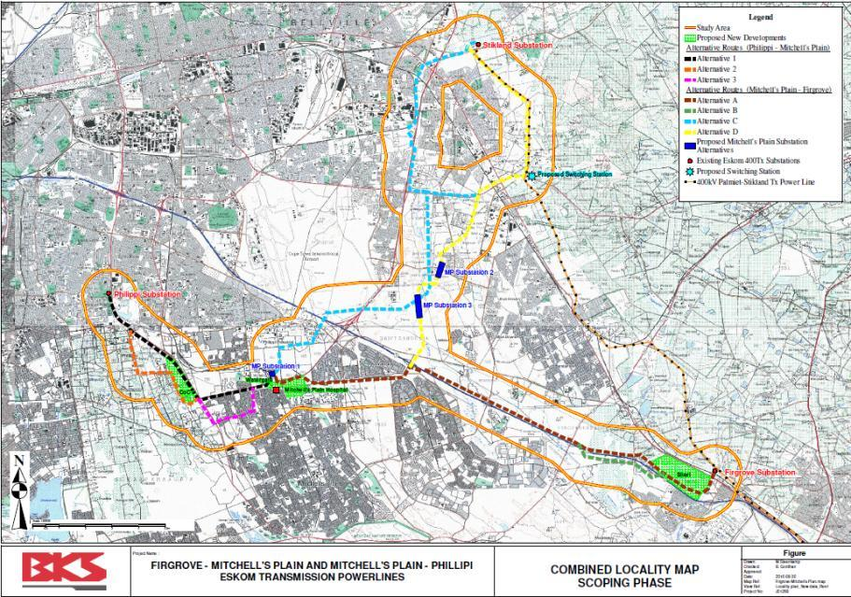

APPENDIX B: SENSITIVE AVIFAUNAL AREAS

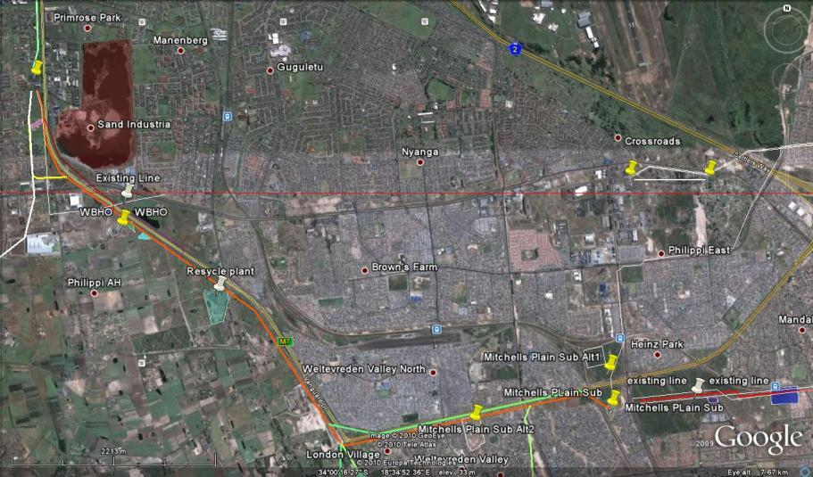
Sensitive
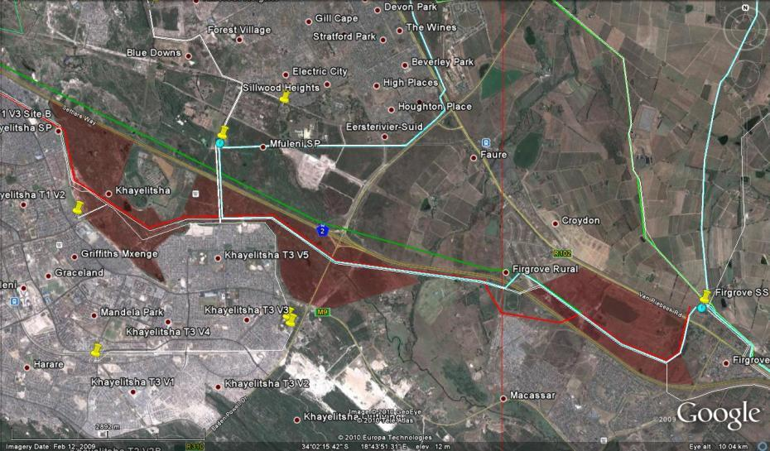
APPENIDIX B: SENSITIVITE AVIFAUNAL AREAS

Sensitive

APPENDIX B: SENSITIVE AVIFAUNAL AREAS
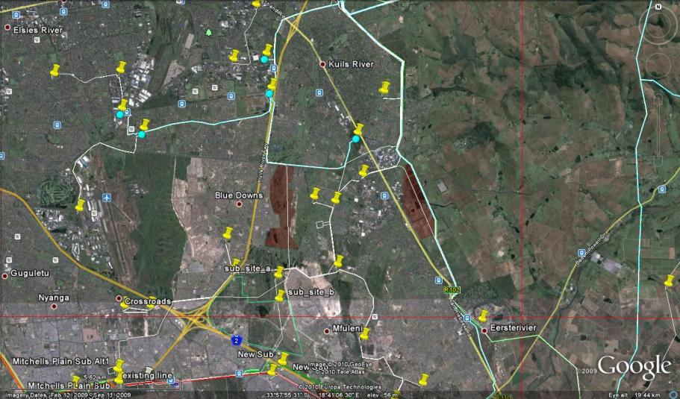
Sensitive

APPPENDIX C BIRD HABITAT

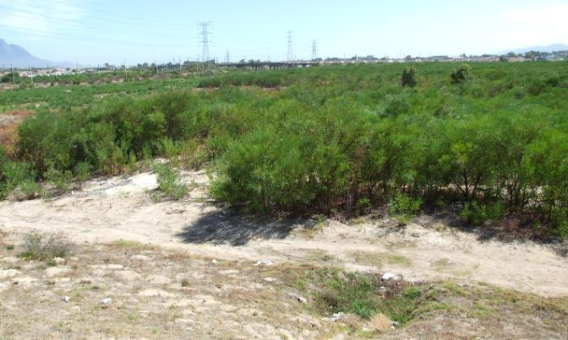

Figure 1: Typical stands of dense alien vegetation in the study area

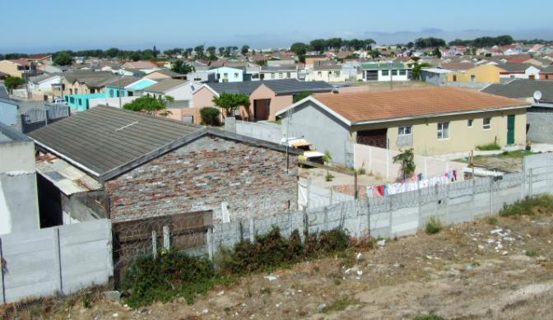
Figure 2: Dense urbanisation in the study area

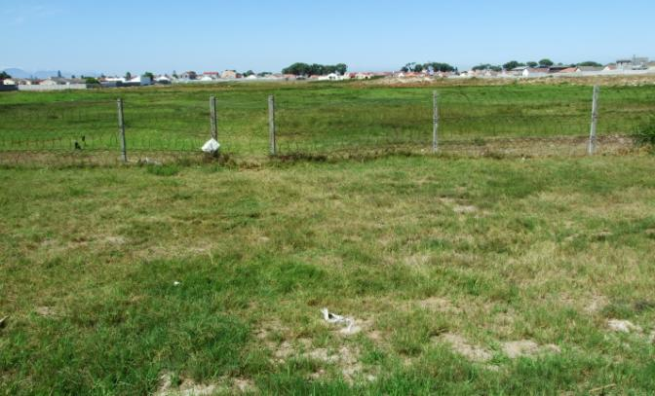

Figure 3: There are a few remaining open areas in the study area

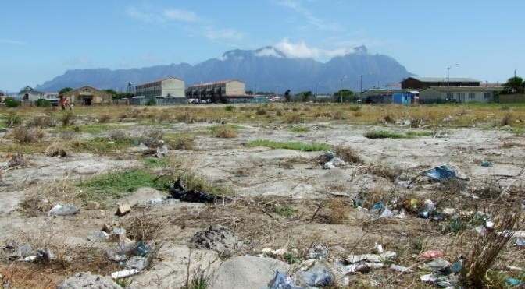

Figure 4: The majority of the habitat in the study area bears evidence of heavy impacts

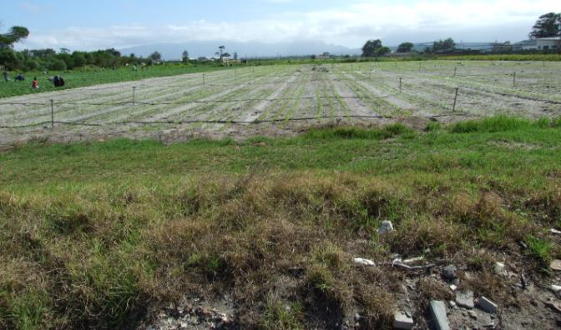
Figure 5: There is limited agricultural activity in the study area, most is located south of Philippi

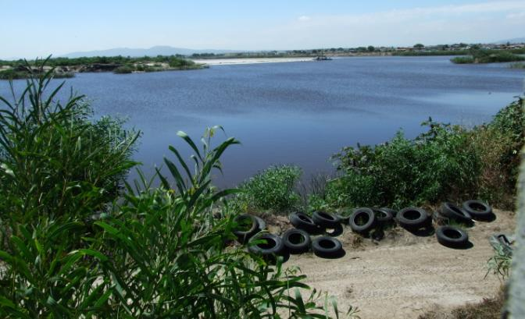

Figure 6: Man-made wetlands serve as attractants for a number of bird species in the study area

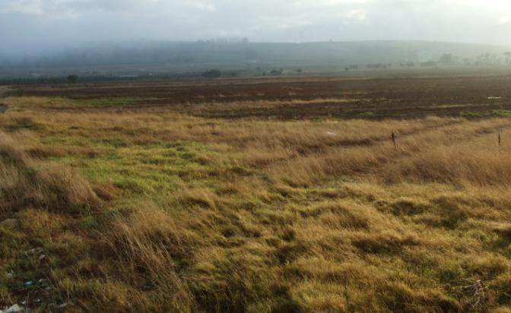

Figure 7: Arable lands that have reverted to a form of grassland is an important bird habitat in the study area

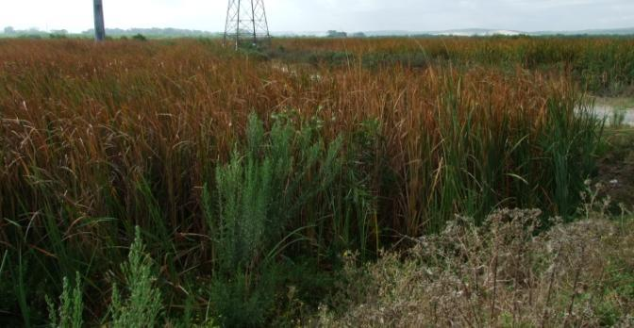
Figure 8: The Kuils River with its associated wetlands is the most prominent drainage line in the study area

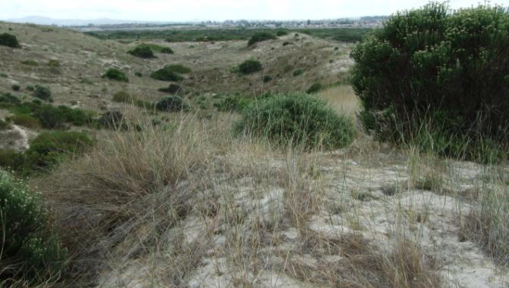

Figure 9: Driftsands Nature Reserve is a degraded island of natural vegetation in the study area

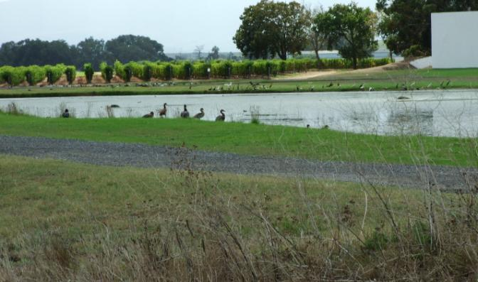
Figure 10: Artificial water bodies are an important habitat for water birds in the study area

